IS MA MALE OR FEMALE STAFF EMPLOYEE SHOW HO SEPARATELY OR BTAI KITNA active ha or jab CRITICAL: Expiring Inventory1 products are expiring within 30 days usko higjlight kera
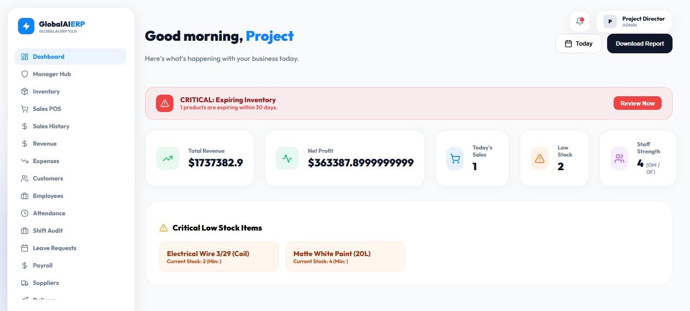
Agar company ka name likhna ho kesa likha ga
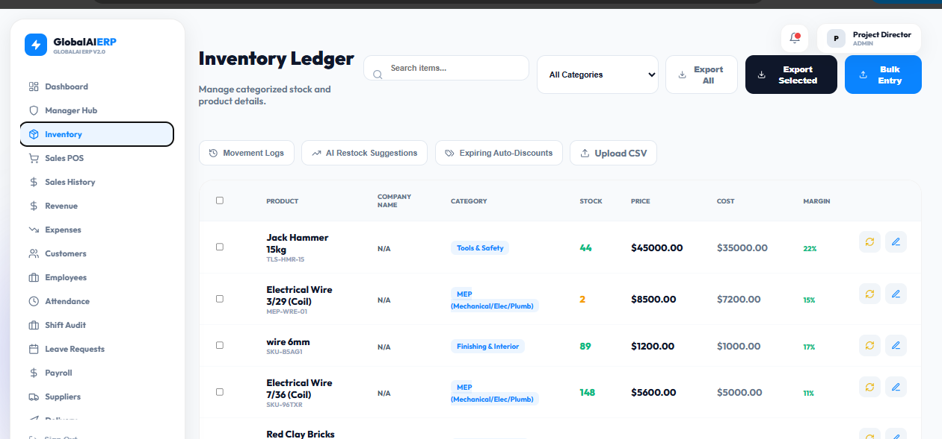

Or jab new employee bnai to uska password odher sa create ho or password ma special character bhi use ho OR FORGET PASSWORD WALA BHI DALO
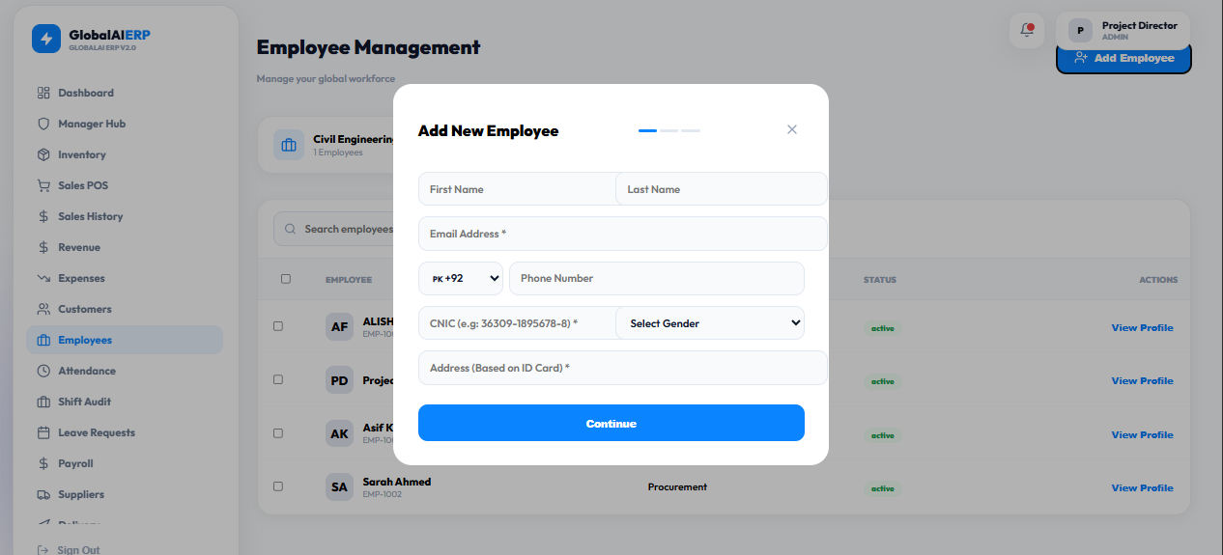

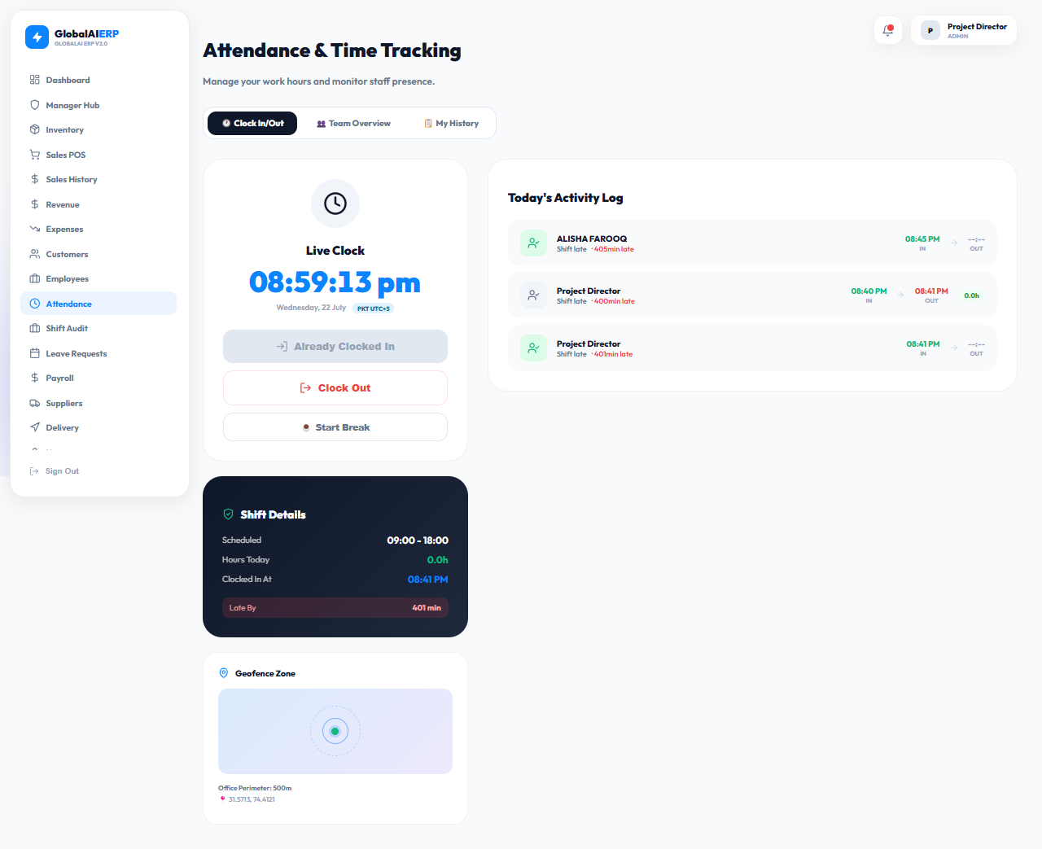
Or is ma admin ka pass ho location change ker sakta ha

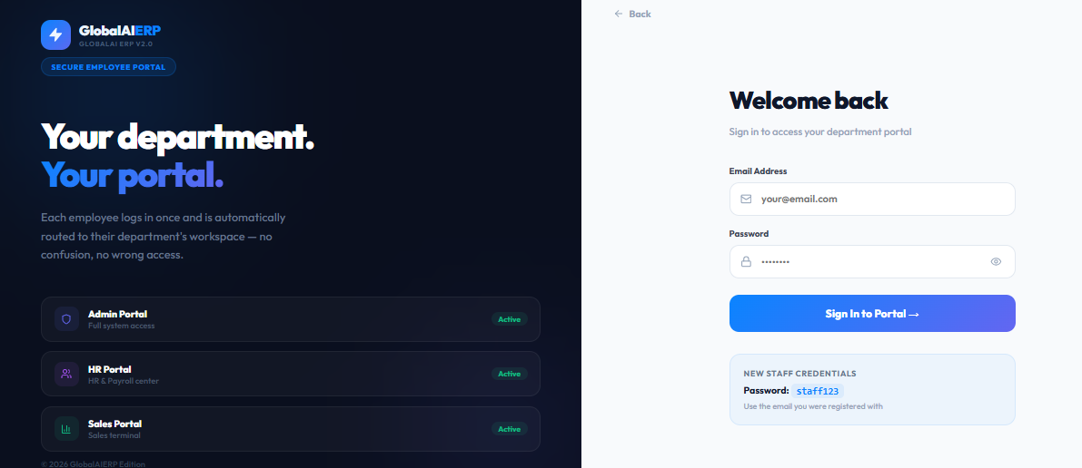

STAFF123 KO REMOVE KER DO

